Mass-Spring Simulator – User’s Manual

**Installation**

*NOTE: If you have Python 2.7 installed and Pip can be run from anywhere (i.e the environment variables know where Python is), you don’t need to follow the first few steps.*

To be able to run this software, you should have Python 2.7. It might work on other versions but this is what it was programmed on.

<https://www.python.org/download/releases/2.7/>

Download and install the one for Windows (either one should work).

After installation, navigate to your system environment variables (on Windows 10, search in the start menu “Edit Environment Variables”). Edit the Path variable to include the Python27 directory, as well as the Scripts folder (by default it would be C:\Python27 and C:\Python27\Scripts). This is so that you can use Python and any scripts like Pip from anywhere on your computer.

*Installing the proper libraries.*

You can now run installLibs.bat. If you have set up your environment variables properly after installing Python, this will use Pip to install four libraries: NumPy, PySide, MatPlotLib, and Pygame. Each is needed to run the software.

**Using the Software**

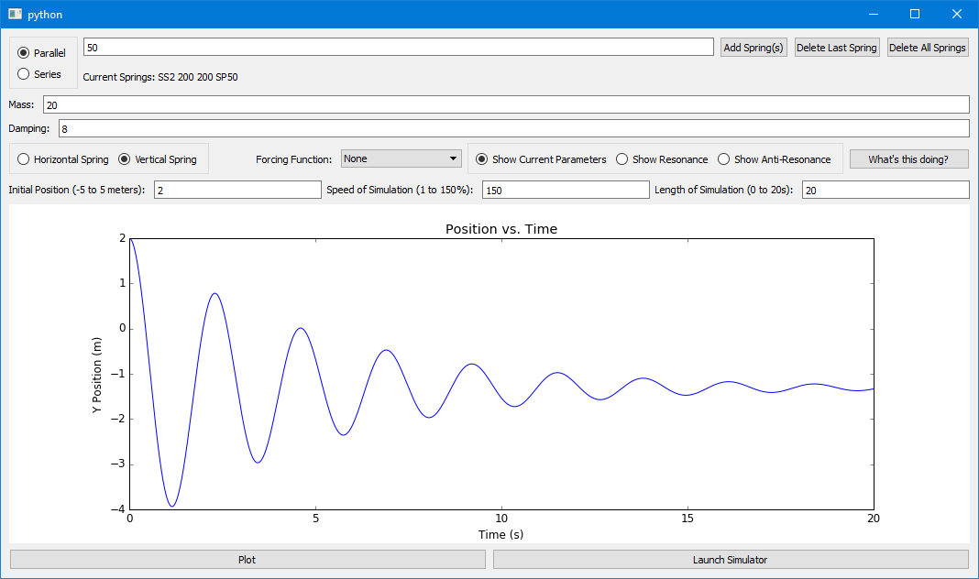

To run the software, run the batch file titled MassSpringSim.bat. This will run GUI204.py, which is the GUI for the software.

To add springs, you can type their stiffness values into the textbox at the top. Typing something like “50 50 50” with the Parallel circle checked will produce three springs in parallel, each with a stiffness of 50. The same input, with Series checked, will produce a set of three springs, connected in series, each with a stiffness of 50. You MUST at least one spring with an acceptable stiffness to run the simulation.

Other parameters, such as mass, damping and initial position, can easily be added. If you wish to add a forcing function, it can be selected from a drop-down list. If, perhaps, you would like to see an example of resonance or anti-resonance, check one of those circles. This uses preset parameters that show how a system can be assisted by a force to keep growing or decreasing in amplitude.

By default, the simulation will show a mass-spring system moving in the horizontal direction. If you would like to see a hanging mass, select the Vertical Spring circle.

Finally, the speed of simulation and length of simulation can be assigned. The speed of simulation allows you to play the simulation in fast or slow-motion, and of course the length of simulation specifies how much time you would like to see of the simulation.

Hitting the Plot button will show a plot on the GUI of the mass’ position with respect to time. Hitting Launch Simulator will pass all necessary parameters to spring.py and run a simulation of the system. This simulation can be replayed or closed if you wish to make changes to parameters.